#### OFFICIAL HANDBOOK

### OF RULES AND REGULATIONS

## TABLE OF CONTENTS

# 

1 – Mission Statement and Objectives Page 2

2 – Bylaws Pages 3 to 12

3 – General Rules and Regulations Pages 12 to 18

4 – Equipment Pages 18 to 21

5 – Scoring of Cow Work / Herd Work Pages 21 to 26

6 – Scoring & Penalties of Reining Pages 27 to 29

7 – Reining Patterns Pages 32 to 43

8 – Classes Pages 44 to 47

9 – Payouts, Judges, Year end awards Page 48 to 49

# MISSION STATEMENT

The mission of the Ontario Reined Cow Horse Association

is to promote the reined cow horse in Ontario through education, participation and mentorship.

# OBJECTIVES

* **To promote and encourage the showing of the reined cow horse in the Province of Ontario;**
* **To develop and enforce suitable and proper standards of performance and judging;**
* **To educate the members and spectators in the training and exhibition of reined cow horses.**

**Table of Contents - Bylaws**

Article 1 – TITLE

Article 2 – MEMBERSHIP

Section 1 – Availability

Section 2 – Admission

Section 3 – Dues

Section 4 – Life Membership

Section 5 – Non-Pro Status

Article 3 – MEETINGS

Section 1 – Annual Meeting

Section 2 – Special Meetings

Section 3 – Quorum

Article 4 – DIRECTORS / OFFICERS

Section 1 – Officers and Executive Committee

Section 2 – Salaries

Section 3 – Appointed

Section 4 – Reporting Requirements

Section 5 – Authority

Section 6 – Vacancies

Section 7 – Quorum

Section 8 – Absenteeism

Section 9 – Good Faith

Article 5 – ELECTION OF OFFICERS

Section 1 – Term of Office

Section 2 – Nominations

Section 3 – Voting

Section 4 – Elections Auditor

Section 5 – Voting Tie

Article 6 – DUTIES OF DIRECTORS / OFFICERS

Section 1 – President

Section 2 – Vice-President

Section 3 – Secretary

Section 4 – Treasurer

Section 5 – Directors

Section 6 – Removal

Section 7 – Vacancies

Article 7 – MISCELLANEOUS PROVISIONS

Section 1 – Signing Authorities

Section 2 – Written Notice

Section 3 – Waiver of Notice

Section 4 – Teleconferencing

Section 5 – Explanation

Article 8 – ANNUAL STATEMENTS

Article 9 – INDEMNIFICATION

Article 10 – AMENDMENTS

Article 11 – DISSOLUTION OF THE ASSOCIATION

# Article 1 – TITLE

This organization has been incorporated under the laws of the Province of Ontario in 2005 and is known as the Ontario Reined Cow Horse Association (ORCHA) and shall at all times be operated as a non-profit organization in accordance with the laws of the Province of Ontario and Dominion of Canada.

# Article 2 – MEMBERSHIP

Section 1 – Availability

Membership is open to any individual of good character and reputation who has an interest in reined cow horses and the promotion of the reined cow horse.

All riders and horse owners must be members of ORCHA to show in ORCHA sanctioned classes at ORCHA approved shows. All riders must be members of ORCHA to show at all ORCHA sanctioned shows, jackpots, or to participate at practices, classes, shows, clinics, workshops or any other club events.

Section 2 – Admission

Members shall be admitted and retained in accordance with the rules and regulations of the Ontario Reined Cow Horse Association.

Section 3 – Dues

Each member of the Association shall pay annual membership dues to ORCHA. Said dues are due and payable at the commencement of each fiscal year. The fiscal year of the Association shall be October 1 through September 30 of each year. All membership dues and charges for the Association's publications shall be set by the Board of Directors.

Section 4 – Non-Pro Status

A Non-Professional in this association may not train horses or horse riders for direct or indirect remuneration in any equine discipline. Non-Pro status can be re-obtained after three (3) years of non-acceptance of any remuneration in any equine discipline, with Board approval.

# Article 3 – MEETINGS

Section 1 – Annual Meeting

The annual meeting of the Association shall be held at a time and place designated by the Board of Directors. Notice of the membership meetings will be printed in the Association's official publication or directly presented to the members by Canada Post mail or electronic mail.

Section 2 – Special Meetings

Special meetings of the membership may be called by the Board of Directors to be held at a time and place designated by the Board of Directors. Notice for special meetings will be given in the official publication of the Association or through special mailing, regular or electronic, to each member at least thirty (30) days prior to the meeting. Business transacted at all special meetings shall be confined to the objects stated in the call and notice of the meeting and meetings germane thereto.

Section 3 – Quorum

At any meeting of the Association, whether it be an annual meeting or a special meeting, the members present shall constitute a quorum regardless of the number actually present.

# Article 4 – DIRECTORS / OFFICERS

Section 1 – Officers and Executive Committee

There shall be nine (9) Directors elected by the members. Four Directors to be elected for a 2-year term (2011/2013/2015 etc.) Five Directors to be elected for a 2-year term (2012/2014 etc.). The Directors then will elect the President, Vice-President, Secretary and Treasurer. The remaining members will serve as Directors.

Section 2 – Salaries

There are no salaries.

Section 3 – Appointed

Its Board of Directors shall manage the business of the Association. The Board of Directors shall be comprised of the President, Vice-President, Treasurer, Secretary

and five (5) elected Directors, or as many as deemed necessary from the elected Board of Directors. The appointed Directors shall hold office for a period of two (2) years. In the event that ORCHA has retained an Executive Director as set forth hereinafter in these By-laws, the said Executive Director shall not be a member of the Board of Directors. All members of the Board of Directors must be members of ORCHA.

Section 4 – Reporting Requirements

The Board of Directors shall have general charge of the affairs, finances and property of the Association, to which they shall make an annual report to the membership at the annual meeting.

Section 5 – Authority

In addition to the powers and authorities these By-laws expressly confer upon them, the Board of Directors may exercise all such powers of the Association and to all such lawful acts that are not prohibited by statute or by these By-laws.

Section 6 – Vacancies

The Board of Directors shall be empowered to fill vacancies occurring in the Board. Any vacancy occurring in the Board may be filled by the affirmative vote of a majority of the remaining directors. A director elected to fill a vacancy shall serve the unexpired term of his/her predecessor.

Section 7 – Quorum

A quorum of the Directors in office shall be necessary to transact business of the Association. A quorum for the purposes of these By-laws is defined as five (5) members of the Board of Directors. Once it is established that a quorum exists, a majority of such quorum shall then decide upon any questions that may come before the meeting and shall be binding as though the full Board of Directors were sitting.

Section 8- Absenteeism

Any Director who misses more than two (2) unexcused meetings per year may be removed for cause.

Section 9 – "Good Faith"

A Director of the Association shall stand in a fiduciary relation to the Association and shall perform his or her duties as a Director, including his or her duties as a

member of any committee of the Board upon which he or she may serve, in good faith, in a manner he or she reasonably believes to be in the best interest of the Association, and with such care, including reasonable inquiry, skill and diligence, as a person of ordinary prudence would use under similar circumstances. In performing his or her duties, a Director shall be entitled to rely on good faith information, opinions, reports or statements, including financial statements and other financial data, in each case prepared by any of the following:

1. One or more officers or employees of the Association whom the Director reasonably believes to be reliable and competent in the matters presented;
2. Counsel, public accountants or other persons as to matters, which the Director reasonably believes to be within a professional and expert competence of such person;
3. A committee of the Board upon which he or she does not serve, duly designated in accordance with law as to matters within its designated authority, which a director reasonably believes to merit confidence.

A Director shall not be considered to be acting in good faith if he or she has knowledge concerning the matter in question that would cause his/her reliance to be unwarranted. In discharging the duties of their respective positions, the Director shall at all times use the skill and diligence a person of ordinary prudence would use in similar circumstances. So long as the Director uses such skill and diligence as a person of ordinary prudence would use under similar circumstances, he or she shall not be held personally responsible for any actions taken on behalf of the Association.

# Article 5 – ELECTION OF OFFICERS

Section 1 – Term of Office

The election of officers and directors shall be held at the Annual General Meeting of the association at the time and place designated by the Board of Directors.

So as to have continuity in the officers of the Association:

* The President shall be elected for a one (1) year term, and
* The Vice-President shall be elected for a two (2) year term, and
* The Treasurer shall be elected for a one (1) year term, and
* The Secretary shall be elected for a two (2) year term, and
* The remaining officers shall be elected for a two (2) year term
* Thereafter the election shall be for those positions that have served their full term and persons so elected shall serve a two (2) year term.

Section 2 – Nominations

Nominations will be taken from the floor at the Annual General Meeting. Nominees do not have to be present, however, acceptance of nomination in writing is required from the nominee.

Section 3 – Voting

Each member of the Association, in good standing at the time of the election who is entitled to vote, must be present at the annual meeting in order to vote. There will be no proxy voting accepted by ORCHA.

Section 4 – Elections Auditor

The election of officers and directors at the annual meeting shall be conducted by persons duly appointed at the annual meeting for that purpose.

Section 5 – Voting Tie

In the event of a tie, the President will vote to break the tie. If the tie is for the position of President, then the Past President shall break the tie.

# Article 6 – DUTIES OF DIRECTORS / OFFICERS

Section 1 – President

The President shall:

* Be the Chief Executive Officer of the Association;
* Preside at the meetings of the Executive Committee, the Board of Directors and meetings of the Members;
* Ensure that all orders of the Directors and of these By-laws are implemented;
* Perform all other duties as are normally incident to the office of President;
* Sign all cheques, notes, bills of exchange, deeds or other formal documents.

Section 2 – Vice President

The Vice-President shall:

* Be vested with all the powers and shall perform all the duties of the President in the absence or disability or refusal to act of the President;
* Have such powers and duties, if any, as may from time to time be assigned to them by the Board.

Section 3 – Secretary

The Secretary shall:

* Have charge of the corporate seal and the minute book of the Association and shall record in such book, minutes of all meetings of the Directors and members, and of such other proceedings as the Board may direct;
* Unless some other Officer is specifically charged with the duty, the Secretary shall keep or cause to be kept such books and records as the Association required to keep under the provisions of the Laws of the Province of Ontario and shall sign with the President or other signing Officer of the Association such instruments as require their signature.

Section 4 – Treasurer

The Treasurer shall:

* Have the care and custody of all the funds and securities of the Association and shall deposit the same in the name of the Association in such bank or banks, depository or depositories as the Board of Directors may direct;
* Unless some other Officers specifically charged with the duty, shall keep or cause to be kept the books of account, which the Association is required to keep under the provisions of the Province of Ontario.

Section 5 – Directors

The Directors shall be charged with the daily operational responsibilities of the Association, including but not limited to decisions necessary for continuity and those requiring immediate attention. Any action taken by the Officers without the prior approval of the Board of Directors, or action permitted by these By-laws, requires a quorum of the Directors / Officers. For the purposes of these By-laws, a quorum shall consist of five (5). The Directors / Officers of the Association shall not, without prior Board of Directors' approval, bind the Association to any contractual obligations.

Section 6 – Removal

Any Officer or Director elected by Membership, may be removed by the Board of Directors whenever in its judgment, the best interests of ORCHA would be served thereby.

Section 7 – Vacancies

If the office of any officer, or agent, one or more, becomes vacant for any reason, the Board of Directors may choose a successor or successors, who shall hold office for the unexpired time in respect of which such vacancy occurred.

Vacancies in the Board of Directors, including vacancies resulting from an increase in the number of Directors, shall be filled by a majority of the remaining members of

the Board no less than a quorum, and each person so elected shall be a Director until the successor is elected by the membership, who may make such election at the next annual meeting of the membership, or at any special meeting duly called for that purpose and held prior thereto.

# Article 7 – MISCELLANEOUS PROVISIONS

Section 1 – Signing Authorities

All cheques or demands for money and notes of the Association shall be signed by such officer or officers or their designees, as the Board of Directors may from time to time designate.

Section 2 – Written Notice

Whenever written notice is required to be given to any person it may be given to such persons either personally or by sending a copy thereof through the mail, or by telefax, charges prepaid to his or her address appearing on the books of the Association membership list, or supplied by him to the Association for the purpose of notice. If a notice is sent by mail, it shall be deemed to have been given to the

person entitled thereto when it is deposited in Canada Post Mail. If the notice is sent by way of telefax or electronic mail, it shall be deemed to have been given to the person entitled thereto when transmission occurs. Such notice shall specify the place, day and hour of the meeting and/or hearing and in the case of a special meeting of the membership, the general nature of the business to be transacted.

Section 3- Waiver of Notice

Whenever any written notice is required by statute, or by the By-laws of the Association, a waiver thereof in writing, signed by the person or persons entitled to such notice, whether if before or after the time stated therein, shall be deemed equivalent to the giving of such notice. Except in the case of a special meeting of the membership, either the business to be transacted or the purpose of the meeting need be specified in the waiver of notice of such meeting. Attendance of a person at any meeting shall constitute a waiver of notices of such meeting, except where a person attends a meeting for the expressed purpose of objecting to a transaction of any business because the meeting was not lawfully called or convened.

Section 4 – Teleconferencing

One or more of the Directors may participate in a meeting of the Board by means of conference telephone or other electronic device equipment by means of which all persons participating in the meeting can communicate with and hear each other.

Section 5- Explanation

The words Association and the acronym ORCHA used in this document are synonymous and are used to refer to the Ontario Reined Cow Horse Association.

# Article 8 – ANNUAL STATEMENTS

The President and Board of Directors shall present at each Annual General Meeting a full and complete statement of the business and affairs of the Association for the preceding year. Such statements shall be prepared and presented in whatever manner the Board of Directors shall deem advisable and need not be verified by a Certified Public Accountant.

# Article 9 – INDEMNIFICATION

The Association shall indemnify each of its Directors, Officers, employees and committee members whether or not then in service as such, against all reasonable expenses actually and necessarily incurred by him or her in connection with the defense of any litigation to which the individual may have been a party because he or she was a Director, Officer or employee of the Association. The individual shall have no right to reimbursement however in relation to matters as to which he or she has been adjudged liable to the Association for negligence or misconduct in the performance of his or her duties, or was derelict in the performance in his or her duty as a Director, Officer or Employee by reason of willful misconduct, bad faith, gross negligence, or reckless disregard or the duties of his or her office or employment.

The right to indemnify for expenses shall also apply to expenses of suits, which are comprised or settled if the Court having jurisdiction of this matter shall approve such settlement.

The foregoing right of indemnification shall be an addition to, and not exclusive of, all other rights which such Director, Officer or Employee may be entitled by insurance.

# Article 10 – AMENDMENTS

Amendments to the By-laws must be presented to the ORCHA office at least sixty (60) days prior to the Annual General Meeting and written notice of the proposed amendments will be given in the ORCHA official publication or by a special mailing

to the membership at least thirty (30) days before the Annual General Meeting. These amendments will be considered and voted on at the Annual General Meeting, and must be passed by the majority of the members voting in person.

**Article 11 - DISSOLUTION OF THE ASSOCIATION**

In the event of the dissolution of the Association for any cause, whatsoever, the property and assets of the Association after all liabilities have been met, shall not, in any event, be distributed among the members, but shall be disposed of by donating to another organization having similar non-partisan, non-profit objectives.

# GENERAL RULES AND REGULATIONS

A – DISCIPLINARY PROCEDURES

B – CAUSES FOR DISCIPLINARY ACTION – ABUSE

C – UNSPORTSMANLIKE CONDUCT

D – FORFEITURES

E – FAILURE TO PAY

F – COURT OF LAW CONVICTIONS

G – CONVICTIONS BY OTHER EQUINE ORGANIZATIONS

H – DISCIPLINE BY NRHA OR REINING CANADA

I – SHOWS

J – YEAR END AWARDS

K – APPOINTMENTS AND EQUIPMENT

L – COW WORK – SCORING AND PENALTIES

M – HERD WORK – SCORING AND PENALTIES

N – REINING – SCORING AND PENALTIES

O – PATTERNS

Q – CLASSES

***Guidelines for rules not covered by the ORCHA rule book will default to the AQHA rule book where applicable.***

***Exhibitors are responsible to know the rules.***

***GENERAL RULES AND REGULATIONS***

# A – DISCIPLINARY PROCEDURES

Section1 – Membership in the Association carries responsibilities as well as certain rights. Any member of the Association may be disciplined, fined or suspended upon a showing of good cause. Any non-member may be denied membership and the privileges relating thereto whenever it shall be established by satisfactory evidence to the ORCHA Executive Board that such non-member is not a worthy candidate.

Section 2 – Anyone who becomes a member of the Association accepts to be bound by all the rules and regulations of the Association and renounces any recourse that he or she may have against the Association in connection with the enforcement of those rules.

Section 3 – Whenever anyone believes that conduct at an ORCHA approved event by a member or non-member warrants disciplinary actions, he or she must file within ten (10) days of the actual incident, and/or within ten (10) days of having gained knowledge of the incident, a protest in writing with the ORCHA Office. Timely filing will be determined by the postmark on the envelope. Any protest must be accompanied by a bank draft, money order, certified cheque or cash in the amount of One Hundred ($100.00) Dollars to be considered validly filed. The filings of a negative show representative's report and/or judge's grievance setting out the conduct warranting disciplinary action will also constitute a validly filed protest. The $100.00 protest fees are non-refundable in every instance of an unfounded protest, or in a case of finding, a portion of the protest fees maybe returned to the protester, but not to exceed 50% and the amount will be determined by the Board of Directors. Upon receipt of all validly filed protests in the ORCHA office, the ORCHA President and/or Executive Committee will designate the Protest Review Committee to investigate the protest and make any recommendation.

Section 4 – Upon receipt by the ORCHA Office of any validly filed protest, notification shall be sent to the person accused of a violation of these rules at that person's last known address. That notice shall contain a copy of the protest and shall advise the accused of the disciplinary procedure to be followed.

Section 5 – The ORCHA President and the ORCHA Board shall form the Protest Review Committee. The Protest Review Committee shall have full carriage of the investigation, including the power to assign one or more members to carry out the investigation of facts.

Section 6 – Upon reviewing the investigation report, the Protest Review Committee may choose to refer the matter to the appropriate standing committee for review. If the Protest Review Committee finds the matter is not sufficiently serious to warrant

a hearing, all parties will be advised accordingly. If however, the Protest Review Committee finds that a hearing is warranted, the person accused of the violation shall be given not less that thirty (30) days written notice of a time and place for a hearing before the ORCHA Executive Board. The accused shall have an opportunity to appear at the hearing, with or without counsel, and to be heard and to present evidence and testimony on his or her own behalf and to hear and refute any evidence offered against him or her. Should the accused choose to appear at the hearing, the accused does so at his or her own expense. Additionally, any costs associated with counsel of the accused shall be borne by the accused, regardless of the outcome of the hearing. The parties will receive a decision from the ORCHA Executive Committee immediately after deliberation. ORCHA may be represented at any such hearing by counsel or an agent who is not a member of the Executive Committee or a member of the Board of Directors.

Section 7 – Proceedings before the ORCHA Executive Committee shall be informal and rules of evidence, both at common law or provided by Ontario rules of civil or criminal evidence, need not be strictly observed. The standard by which admissibility is determined is whether the evidence is such that an ordinary prudent person is willing to rely upon it. As an ORCHA member, participant at an ORCHA approved event or a person appearing before the Executive Committee, the accused person agrees that all witnesses and participants in such hearing shall be immune from any civil liability whatever, including, but not limited to, libel, slander, invasion of privacy, defamation, or product of disparagement, for testimony given in the course of preparation for or at the hearing.

Section 8- In regard to any violation of ORCHA rules and regulations, the Executive Committee shall impose at a minimum the following sanctions:

1. First Offence – not less than 30 days probation
2. Second Offence – not less that 30 days suspension
3. Third Offence – not less than a one-year suspension
4. Lifetime Suspension – where warranted

In addition to the sanctions set forth above, the ORCHA Executive Committee shall have jurisdiction to invoke any or all of the following sanctions, including but not limited to: revocation or denial of membership privileges, revocation of participation privileges in all ORCHA approved events, denial of privilege or access or presence on the show grounds of an ORCHA approved event, denial of privilege to advertise in official publications and/or assessment of a fine.

Section 9 – The Executive Committee and/or its designee will issue a written report including finding of fact and conclusions within a reasonable period of time after the close of the hearing. All parties will receive a copy of the findings of facts and conclusions.

Section 10 – When a member is disciplined or suspended, or a non-member is denied membership privileges, the finding of fact and conclusions will be presented to the ORCHA Board of Directors.

Section 11 – Any suspended member of the ORCHA will not be allowed to participate in any ORCHA approved event as an owner of a horse, rider, or act as an agent in connection with any ORCHA approved event. In the event a suspended member enters an approved event during the period of suspension either as owner, rider or agent, the ORCHA Executive Committee may impose an additional six (6) month period of suspension and all show winnings will be forfeited to ORCHA.

Section 12 – If the ORCHA Executive Committee deems the submission of a protest to be malicious and/or frivolous, appropriate disciplinary action may be taken.

Section 13 – Any member interfering with or attempting to influence the outcome of a protest investigation or hearing may be subject to disciplinary action by ORCHA.

Section 14 – The decision and action of the ORCHA Executive Committee shall be final and binding upon all parties.

Section 15 – All disciplinary hearings shall be held at a location as determined by the ORCHA Executive Committee.

# B – CAUSES FOR DISCIPLINARY ACTION – ABUSE

Section 1 – A member of the association shall not abuse or mistreat any animal in any manner whatsoever on the show grounds. Abuse is defined as an action, or failure to act, which a reasonably prudent person, informed and experienced in the customs, accepted training techniques and exhibition procedures, would determine to be cruel, abusive, inhumane or detrimental to the animal's health.

Section 2 – Individuals will be subject to the disciplinary procedures set forth in Section A if it is determined that there was willful abuse of the horse under any of the following circumstances:

1. The individual physically participates in the abuse of the animal or shows the horse in a condition to be considered abuse.
2. The individual designates him or herself as the exhibitor on the show entry form.

# C – UNSPORTSMANLIKE CONDUCT

Section 1 – Unsportsmanlike conduct will not be tolerated. Unsportsmanlike conduct shall be defined as any action of disrespect, deceit or fraud directed to judges, show management, and show representatives, ORCHA members or other exhibitors.

# D – FORFEITURES

Section 1 – Any rider participating in a class or a division in which he/she is not eligible based on earnings (or the horse he/she is riding is not eligible based on earnings) will be placed on probation for 30 days for the first offence. Second and subsequent offences will result in a 30-day suspension and a fine of $200.00. When a horse/rider is found to be ineligible, the earnings and awards will be forfeited to ORCHA.

Section 2 – Upon receipt of any forfeited earning, ORCHA will redirect the forfeited earnings to the show committee to be redistributed. ORCHA will make corrections to the class placing and earnings in the ORCHA database. It is the responsibility of the ineligible and/or disciplined exhibitor and/or owner to forfeit all earnings, prizes and/or awards to ORCHA.

# E – FAILURE TO PAY

Any member may be suspended and denied privileges of the Association and any non-member, and any non-member approved show or official thereof, may be denied privileges of the Association for failure to pay when due, any obligation owed the Association, ORCHA Official Publication or ORCHA approved show for failure to pay entry fees, stall fees, office charges, premiums or any other fees or charges connected with the exhibitions of reined cow horses; provided, however, that fifteen (15) days before action, written notice of the account due and the intention to suspend and withhold privileges of the Association shall be delivered to such member or non-member. This provision also includes the payment of any costs, fees or obligations for a cheque that is returned to the ORCHA or any show of affiliate that has been deemed by a bank to be paid by an account that contains non-sufficient funds. Any suspension and denial of privileges under this section shall terminate upon full payment of the obligation due.

# F – COURT OF LAW CONVICTIONS

A conviction of an individual under municipal, county, state, provincial or federal law, whether or not ORCHA is involved, may subject the convicted person to discipline by the ORCHA Executive Committee under the terms herein set forth. Any discipline imposed will be stayed pending completion of any statutory appeals. Acceptance of a conviction by ORCHA will be given after notice to the sanctioned individual or entity, which may request a hearing before the ORCHA Executive Committee.

# G – CONVICTIONS BY OTHER EQUINE ORGANIZATIONS

ORCHA Executive Committee may accept suspension rulings pertaining to cruel or inhumane treatment of horses from other recognized equine related associations and state or provincial racing commissions. The effect of such acceptance is to suspend the individual from ORCHA membership privilege, or for non-members to deny membership privileges, for a length of time equal to the suspension for which reciprocity is given. Acceptance of such rulings by ORCHA will be given after notice to the sanctioned individual or entity, who may request a hearing before the ORCHA Executive Board to present lack of due process by the reporting association to merit ORCHA's refusal to give reciprocity.

# H – DISCIPLINE BY ORCHA

ORCHA will honour any suspension rulings of the ORCHA Executive Board.

# I – SHOWS

ORCHA will not sponsor a show that does not have classes that are beneficial to all competitors with the exception of when a show is beneficial to ORCHA upon vote from directorship. The organization will from time to time sanction specific show events. These events may or may not be sanctioned by the Ontario Reined Cow Horse Association. In either event, the rules of the ORCHA will govern.

Any show wishing to be sanctioned by the organization must submit an application by the deadline set. Special cases will be considered by the Board of Directors and may be approved on their merit. A show committee may retain up to 50% of entry fees.

# J – YEAR END AWARDS

The organization will recognize achievements of its members by annually presenting an award to the highest money earner (Champion) and the second highest money earner (Reserve Champion) in each class based on the total annual monies earned at the ORCHA sanctioned events in one calendar year (October 1st to September 30th). Tabulations are calculated as indicated in the Class conditions only from the day the paid membership received to the end of the award year.

Ties will be broken by higher cow points; if equal cow points, 2 awards will be given.

In order to qualify for year-end awards, Champion and Reserve riders must have competed in the said class at least 50% of the total times offered at shows. In order for monies earned to be eligible for year-end awards, rider and horse owner must be a member in good standing of ORCHA.

# K – APPOINTMENTS AND EQUIPMENT

Horses shall be shown astride with a western saddle. Riders must wear a western hat or helmet approved for riding by an equine organization, Western boots, and long sleeve shirt. Chaps or chinks and spurs are optional. Use of training equipment will not be permitted in the show arena on the day of an ORCHA approved show within one hour of the start of the show.

If the rider or horse is not wearing an exhibitor number upon entering the show pen, the rider will be disqualified.

On an ORCHA approved show day, and until the conclusion of the show, any persons entering the show pen must be wearing a western hat or helmet and long sleeve shirt. Judges, at their discretion, may authorize adjustment to attire due to weather conditions.

Bits and equipment described below are required for all classes.

Horses six years old and older must be shown in a bit; horses five years old and younger may be shown in either a bit, hackamore or snaffle bit at the discretion of the exhibitor, or as specified in the Class Conditions description.

1. Bits

1. Curb Bits – All curb bits must be free of mechanical devices and should be considered a standard western bit. Description of a standard legal western bit includes:
   1. 8 1/2" (215mm) maximum length. Shanks may be fixed or loose.
   2. Concerning mouthpieces, bars must be round, oval or egg shaped, smooth and unwrapped metal of 5/16" to 3/4" (8mm to 20mm) in diameter, measured 1" (25mm) from the cheek. They may be inlaid, but must be smooth or latex wrapped. Nothing may protrude below the mouthpiece (bar), such as extensions or prongs. A three (3) piece, connecting ring of 1-1/4" (32 mm) or less in diameter, or a connecting flat bar of 3/8" to 3/4" (10mm to 20mm) measured top to bottom with a maximum length of 2" (50mm) measured top to bottom with a maximum length of 2" (50mm), which lies flat in the horse's mouth is acceptable.
   3. The port must be no higher than 3-1/2" (90mm) maximum, with rollers and covers acceptable. Broken mouthpieces, half-breeds and spades are standard. When a curb bit is used a curb strap or curb chain is required.
   4. Braces, copper port cover and/or having copper smoothly inlaid in the mouthpiece are optional. The use of martingale or tie-down is prohibited. No wire or rawhide device may be used in conjunction with the bit other than the leather chinstrap or single chain curb strap. Leather chinstraps or single chain curb straps must be flat and at least 1/2 inch wide. A broken strap or chain is not necessarily cause of disqualification.
   5. In two-rein equipment, bosals (hackamores) may be of any size, shall be round in shape and constructed of uniform braided rawhide or leather and have a non-metal flexible core. No iron or foreign substance may be used. Fingers between the reins are permitted. No gimmick of any kind may be used in conjunction with the bosal.
   6. The same bridle or hackamore must be used throughout the class. If there is a finals, an equipment change is allowed for the finals; however, the same bridle or hackamore must be used throughout the finals.
   7. Snaffle bits shall be either "D" or "O" ring type, no larger than 3 inches in diameter on the inside of the ring. They must have a broken mouthpiece being a minimum of 3/8 inch in diameter from the corners, with a gradual taper ending in no less than 5/32 of an inch at the middle of the bit. These bits must be such that when the reins are pulled, no undue leverage is applied. A leather or other woven material chinstrap of any width is to be used. No iron, chain, or other material may be used. Reins are to be attached above the chinstrap. Two hands must be used on the reins.
2. Spade Bit – A spade bit or a bit having the following characteristics may be used in any of the classes. Said characteristics shall be: one with an unbroken bar mouthpiece with one inch or higher port measured from the bottom of the bar to the top of the port. There must be an operable cricket inside the port of the bit. The diameter of the bar must be a minimum of 3/8 inch. The cheeks must be connected at the bottom. The overall length of the bit shall not exceed 8 1/2 inches. Optional tongue release shall not exceed 3 inches in width.

NOTE: If at anytime during a performance a piece of equipment breaks, the rider may continue provided the broken equipment does not pose a hazard to the rider and/or is not cruel to the horse. If a rider is unable to continue because of the broken equipment the rider will be excused with a score of zero.

2. Romal Reins

The reins can be held in either hand with hand around reins. The non-rein hand must be on the romal. (The keeper, or hobble, that attaches the romal to the reins is considered to be a part of the romal.) The non-rein hand is not allowed, at any time, to touch the reins or a score of zero (0) will be applied. The rider is allowed to shorten the reins while the horse is in motion as long as their hands are held in a legal manner. Whenever this handbook refers to romal, it means an extension of braided material attached to closed reins. This extension shall be carried in the free hand with a 16-inch (40cm) spacing between the reining hand and the free hand holding the romal. When using romal reins, the rider's hand shall be around the reins with the wrists kept straight and relaxed, the thumb on top and the fingers closed lightly around the reins. When using a romal, no fingers between the reins are allowed.

The romal shall not be used forward of the cinch or to signal or cue the horse in any way. Any infraction of this rule shall be penalized severely by the judge.

3. Split Reins

1. When used with one hand:
   * + Bridle reins should be held in thumbs up position. No more than index or first finger between reins is allowed.
     + Tails of reins must both be on same side.
2. When used two-handed:
   * + Tails of reins must be crossed on the opposite side of the neck.
     + Reins should be used with thumbs in UP or IN position.
     + Plow reining is not allowed.

4. Bosal Reins

* + - Two hands allowed; if used one-handed, fingers are allowed between reins.
    - Thumbs up
    - No plow reins permitted
    - Mecate is permitted

# L – COW WORK - SCORING & PENALTIES

GENERAL DESCRIPTION – Credit must always be given when applicable, even when there is a penalty involved. When the judge is in doubt, benefit always goes to the contestant. The scoring system is based on 60 – 80 points. Half points may be used. The contestant is judged from the time he/she enters the arena until he/she completes the pattern. The judge is instructed to pay particular attention to any suspected attempt to alter the horse's tail and score accordingly.

SCORING SYSTEM – The scoring system for ORCHA approved classes/events is based upon a 60 – 80 point system. The lowest score possible is 60 points and the highest score possible is 80 points. The average score for a typical work is 70 points.

TIE FOR FIRST PLACE – In case of a tie for first place, the highest cow work score will be used to break the tie. In the event both cow work scores are the same, the tied contestants will have a work-off down the fence or may flip a coin if mutually agreed. Ties below first place will split earnings and points.

TWO JUDGE SYSTEM – Both scores are combined.

THREE JUDGE SYSTEM – Each judge scores a separate card, all three scores are then compared and the two closest scores are used, with the odd score being eliminated. (i.e. the three scores are 72, 73 and 75, the total score is 145 (72 and 73) with the high score of 75 being eliminated). If the scores are evenly divided, the lowest score is eliminated (i.e. the three scores are 71, 72 and 73, the total score is 145 (72 and 73) with the lowest score of 71 being eliminated.)

FENCE WORK – RULES FOR JUDGING

Judging begins when the contestant enters the arena. There shall be no schooling between the completion of the rein work and the cow work when the cow work immediately follows the rein work; the penalty for this will be a zero (0).

After a reasonable amount of time the contestant shall take the cow down the fence, making at least one (1) turn each way on the fence. Then the contestant

shall take the cow to an open part of the arena and circle the animal at least once in each direction.

The judge should take into consideration the size of the arena, condition of the ground, and disposition of the cattle in scoring each work. If ground, arena, and/or weather conditions are deemed unfavourable by the exhibitors, they may inform the judge who may elect to alter the required cattle work for safety reasons.

The greater the difficulty of the run, the more credit should be given. The difficulty may be due to the extreme speed or stubbornness of the cow, or the cow's reluctance to move down the fence when sufficiently driven by the contestant. The most controlled cow work with the highest degree of difficulty should be marked the highest. Bad manners exhibited by the horse will be penalized under run content. When enough cows are available, the contestant should receive a new cow if the cow drawn is unreasonably difficult or unworkable. Allowing the horse to quit working before the judge signals for a new cow will result in a zero score. The judge may blow his/her whistle at anytime to terminate the work. A score of zero (0) will be given if the work is not complete at that point. The contestant has the option to continue working even though the judge signals for a new cow. With a multiple judge system, any one of the judges may signal for a new cow. Judging ends when the whistle blows.

A horse should keep working until a judge blows the whistle. If exhibitor quits working before a judge blows the whistle a score of zero (0) will be given.

In the cow work phase of any class, one hand on the horn may be used to prevent fall of the rider. Holding the horn excessively may be penalized under run content.

During the cow work, when a cow leaves the working area, it is automatic that the contestant will receive a new cow and scoring will begin again with the new cow, except when the cow has been forced out of the ring by the horse and rider based on the judge's decision. If this is the case a score of zero (0) will be given.

BOXING – Working the cow on the end of the arena until such time as the contestant has proven the ability of the horse to hold the cow. The horse should exhibit superior cow sense and natural cow working ability without excessive reining or spurring. In the head-to-head working position, the degree of difficulty shall be considered.

TURNING ON THE FENCE – A good turn of the fence may be defined as one in which the cow, while being run down the fence on one side of the arena, is turned in the other direction and held near the same fence while being run in the new direction. During the turn the horse should use himself in a controlled athletic manner, using his hocks to stop and drive out of the turn, while using his front end to balance and turn.

The contestant must get at least one (1) turn in each direction. To be considered a turn, the contestant must be close enough to the cow to be the cause of the turn. The turn must be tight enough so as not to be considered just circling the fence. More than two (2) good turns in each direction should not result in extra credit but also should not be penalized, unless the cow is thereby too exhausted to circle correctly. One (1) turn each way may not necessarily result in extra credit if the horse and/or cow are out of control.

After a reasonable amount of time the contestant shall take the cow down the fence making at least one turn each way on the fence. The contestant shall then take the cow to an open part of the arena and circle it at least once in each direction.

CIRCLING – Maneuvering the cow smoothly at least 360 degrees in each direction without interference from the fence. The circles' size, symmetry, speed, and relative balance from right and left show control. Tightening the circles down with fast head-to-head speed will be a credit situation. The circles should be completed before the cow is exhausted.

# WORKING COW HORSE

**(a)** Both the cow work portion of this event and the reined work portion are mandatory. Scoring emphasis on the cow work portion shall be based on the horse maintaining control of the cow at all times, exhibiting superior cow sense and natural cow working ability without excessive reining or spurring. Failure of an exhibitor to attempt to complete the cow work portion of the class, as well as the

reined work, will result in the exhibitor not being considered an entry in the class. A horse that attempts to complete the cow work and has not been disqualified will be scored accordingly at the judge’s discretion. A horse going off pattern in the reined work will receive a score of zero (0). A horse which attempts both the reined work and the cow work portion may be placed even if disqualified in one portion of the class. (Example: If a horse is disqualified and receives a zero (0) score for the reined work, but scores a 70 for the cow work, its total score would be a 70 and the horse would be eligible for placing.) However, the fall of a horse and rider being judged shall be cause for disqualification and not eligible to be placed.

**(b)** At the discretion of the judge, cow work may be done immediately following each individual’s pattern work or immediately after completion of pattern work by all horses being exhibited.

**(c)** The horse should keep working until judge blows whistle. If exhibitor quits working before the judge blows the whistle, a score of zero (0) will be given.

**(d)** The contestant’s horse shall be penalized for general bad manners for cow work portion such as:

**5 Point Penalties**

* Not getting one turn each way (5 points each way)
* Deliberate spurring or use of the romal forward of the cinch

**3 Point Penalties**

* Biting or striking the cow
* Hanging up on the fence (refusing to turn)
* Exhausting or overworking the cow before circling
* Knocking down the cow without having a working advantage

**2 Point Penalties**

* Going past the corner of the arena before turning the cow when going down the fence

**1 Point Penalties**

* Loss of working advantage
* Horses that run past the cow shall be penalized 1 point for every horse’s length past the cow; when the horse’s buttocks pass the cow’s head by one horse’s length, he is one length past
* Failure to pass middle marker on first turn before turning cow
* Using the corner or the end of the arena to turn the cow when going down the fence
* Each time the arena is crossed to use the opposite fence to achieve a turn
* Slipping a rein

# 0 Score

* Any horse that runs over the cow thus causing the fall complete of horse and/or rider shall terminate the work at that time.
* The judge may blow his whistle at any time to terminate the work
* A score of zero (0) will be charged if the work is not complete at that point
* Turn tail
* Balking
* Out of control – (Any horse that is out of control while working the cow, thus endangering the rider, i.e. crossing the path of the cow, shall be called off the cow)
* Bloody mouth (inside)
* Illegal equipment.
* Leaving the work area before the pattern or work is complete
* Fall of horse or rider
* Schooling of the horse between the rein and cow work when the cow work immediately follows rein work.
* Schooling of the horse between cows if a new cow is awarded.

**(e)** If time and number of cattle permit the judge may, at his discretion, award new cattle to enable the contestant to show his horse’s ability on the cow based on the following criteria:

1) The cow won’t or can’t run;

2) The cow won’t leave the end of the arena;

3) The cow is blind or won’t yield to the horse;

4) The cow leaves the arena.

**(f)** Scoring will be on the basis of 60 – 80, with 70 denoting an average performance. In the event of a tie, the entry with the highest cow work will be declared the winner.

**(g)** The following characteristics of the horse are considered faults:

1. Exaggerated opening of mouth;
2. Hard or heavy mouth;
3. Nervous throwing of head;
4. Lugging on bridle;
5. Halting or hesitation while being shown, particularly when being run out, indicating anticipation of being set up;
6. Losing a cow or being unable to finish a pattern because of a bad cow, the contestant should be penalized at the judge’s discretion;
7. Touching the horse or saddle with the free hand except during the cow work portion of the class where the rider may hold onto the horn.

**(h)** The characteristics of a good working cow horse are:

1. Horse should have an alert, responsive attitude;
2. Horse should be shifty, smooth and have its feet under it at all times;
3. Horse should have a soft mouth and should respond to a light rein;
4. Horse should have a natural, unaltered, relaxed tail carriage;
5. Horse should be able to work at reasonable speed and still be under control of rider;
6. Horse should have a natural head carriage.

**M – HERD WORK – SCORING AND PENALTIES**

**(a)** Judging will begin at the time line. The contestant shall approach the herd with no hesitation, weaving or reluctance on the part of the horse to enter the herd sufficiently deep enough to show his ability to make a cut.

**(b)** The horse shall work quietly, but alertly, causing very little disturbance to the herd of the animal brought out. Credit will be given for driving cattle, clearing the heard by a sufficient distance and setting up a cow while holding it in a working position as near the centre of the arena as possible.

**(c)** The degree of difficulty, eye appeal and the amount of courage in staying on a tough cow will be taken into consideration. The amount of time actually spent working cattle in the 2 1/2 minute period will have a positive effect on the total score. The horse should show a great deal of expression but no ill will toward the animal. Judging will end at the whistle.

**5 Point Penalties**

* Horse quitting a cow
* Losing a cow
* Changing cattle after a specific commitment
* Failure to separate a single animal after leaving the herd

**3 Point Penalties**

* Hot quit
* Cattle picked up/ running into or scattering heard
* Pawing or biting cattle
* Failure to make a deep cut
* Back fence
* Spurring or hitting in front of the cinch at anytime

**1 Point Penalties**

* Loss of working advantage (miss)
* Noise directed by contestant toward cattle
* Working out of position

# 0 Score

* Horse turns tail
* Using 2 hands on the reins in a bridle
* Finders between the reins in a bridle
* Illegal equipment
* Leaving working area before time expires
* Fall of horse or rider
* NOTE: A Judge may blow his/her whistle at anytime to terminate the work. A score of zero will be given if the work is not complete at that time.

**N – REINING – SCORING & PENALTIES**

**(a)** Each contestant will perform the required pattern individually and separately. All horses will be judged immediately upon entering the arena and judging will cease after the last maneuver. Any fault incurred prior to the commencement of a pattern will be scored accordingly.

**(b)** To rein a horse is not only to guide him, but also to control his every movement. The best-reined horse should be willingly guided or controlled with little or no apparent resistance and dictated to completely. Any movement on his own must be considered a lack of control. All deviations from the exact written pattern must be considered a lack of or temporary loss of control, and therefore faulted according to severity of deviation. Credit will be given for smoothness, finesse, attitude, quickness and authority in performing the various maneuvers while using controlled speed.

**(c)** The approved pattern will be used and each contestant will cause his horse to travel at the gait indicated for each part of the pattern. When judging reined work, the judge should refer to the reining portion of the handbook for guidelines.

**(d)** In approved working cow horse classes, any of the eight approved AQHA working cow horse patterns may be used. One of the eight is to be selected by the judge of the class and used by all contestants in the class.

**(e)** Scoring will be on the basis of 60 to 80, with 70 denoting an average performance.

**(f)** The following will result in no score:

1. Abuse of an animal in the show arena and/or evidence that an act of abuse has occurred prior to or during the exhibition of a horse in competition;
2. Use of illegal equipment, including wire on bits, bosals or curb chains;
3. Use of illegal bits, bosals or curb chains; when using a snaffle bit, optional curb strap is acceptable; however, curb chains are not acceptable.
4. Use of tack collars, tie downs or nose bands;
5. Use of whips or bats;
6. Use of any attachment, which alters the movement of or circulation to the tail;
7. Failure to provide horse and equipment to the appropriate judge for inspection;
8. Disrespect or misconduct by the exhibitor
9. Closed reins are not allowed except as standard romal reins.

**(g)** A rider may untangle excess rein, where excess rein may prevent the rider from continuing the pattern, where said excess can be straightened without affecting the performance of the horse, during hesitations, or when settling a horse; rider’s free hand may be used to hold romal in the normal fashion.

**(h)** The following will result in a score of 0:

1. Failure to complete pattern as written:
2. Performing the maneuvers other than in specified order;
3. The inclusion of maneuvers not specified, including, but not limited to
   1. Backing more than 2 strides
   2. Turning more than 90 degrees
4. Equipment failure that delays completion of pattern; including dropping a rein that contacts the ground while horse is in motion.
5. Balking or refusal of command where pattern is delayed;
6. Running away or failing to guide where it becomes impossible to discern whether the entry is on pattern;
7. Jogging in excess of one-half circle or one-half the length of the arena;
8. Overspins of more than 1/4 turn;
9. Fall to the ground by horse or rider

**(i)** The following will result in a reduction of five points:

1. Spurring in front of cinch;
2. Use of either hand to instill fear or praise;
3. Holding saddle with either hand (except in cow work).
4. Blatant disobediences including kicking, biting, bucking, rearing, and striking.

**(j)** The following will result in a reduction of two points:

1. Break of gait;
2. Freeze up in spins or rollbacks;
3. On jog-in patterns, failure to stop or walk before executing a canter departure.
4. On run-in patterns, failure to be in a canter prior to the first marker.
5. If a horse does not completely pass the specified marker before initiating a stop position.

**(k)** Starting or performing circles or figure eights out of lead will be judged as follows: Each time a horse is out of lead, a judge is required to deduct one point. The penalty for being out of lead is accumulative and the judge will deduct one penalty point for each quarter of the circumference of a circle or any part thereof

that a horse is out of lead. A judge is required to penalize a horse one-half point for a delayed change of lead by one stride.

**(l)** Deduct 1/2 point for starting circle at a jog or exiting rollbacks at a jog up to two strides. Jogging beyond two strides, but less than 1/2 circle or 1/2 the length of the arena, deduct two points.

**(m)** Deduct 1/2 point for over or under spinning up to one-eighth (1/8) of a turn; deduct one (1) point for over or under spinning from one-eighth to one-fourth (1/8 to 1/4) turn.

**(n)** A 1/2 point penalty deduction will be given for failure to remain a minimum of 20 feet (6 meters) from the wall or fence when approaching a stop and/or rollback.

**(o)** In patterns requiring a run-around, failure to be on the correct lead when rounding the end of the arena will be penalized as follows: for 1/2 the turn or less, one (1) point; for more than 1/2 turn, two (2) points.

**(p)** Faults against the horse to be scored accordingly, but not to cause disqualification:

1. Opening mouth excessively when wearing bit;
2. Excessive jawing, opening mouth or head raising on stop;
3. Lack of smooth, straight stop on haunches-bouncing or sideways stop;
4. Refusing to change leads;
5. Anticipating signals;
6. Stumbling;
7. Backing sideways;
8. Knocking over markers.

**(q)** Faults against the rider to be scored accordingly, but not to cause disqualification:

1. Losing stirrup;
2. Failure to run circles or figure eights within the markers is not considered a fault depending on arena conditions and size; however, failure to go beyond markers on rollbacks and stops is considered a fault.

**(r)** While horse is in motion, rider’s hands shall be clear of horse and saddle.

**O – PATTERNS**

**(a)** The ORCHA Board of Directors suggests the use of the patterns in the following section at ORCHA approved events. The following Patterns are to be worked a stated, not as drawn. The drawn pattern is just to give the general idea of what the pattern will look like in the arena.

**(b)** Markers are mandatory for all patterns. Markers will be placed on the wall or fence of both sides of the arena to the approval of the judges with the following as a guideline.

* 1. At the centre of the arena
  2. The 1-point penalty marker for cow work shall be placed at each corner of the arena.
  3. The 2-point penalty marker for cow work shall be placed a minimum of 16 feet to a maximum of 24 feet past the 1-point penalty marker.
  4. For herd work, the start line marker shall be approximately 70 feet from the back fence marker to the time line.

The judges shall be located approximately 120 feet from the back of the arena. The placement of the back fence marker shall be at the judge's discretion.

End markers for rein work shall be placed at least 50 feet from end of the arena.

**(c)** Where designated in the pattern for stops to be beyond a marker, the horse should begin the stop after he/she passes the specified marker.

**(d)** Run in Patterns are drawn so that the bottom of the page represents the end of the arena entered by contestants and must be run as such. In the event that an arena has only one gate and it is in the exact middle of the side, that side shall represent the right side of the page the pattern is drawn on.

**(e)** All horses will be judged immediately upon entering the arena and judging will cease after the last maneuver. Any fault incurred prior to the commencement of a pattern will be scored accordingly.

**(f)** All judges decisions are final unless subject to the Self-Adjusted Monitor System.

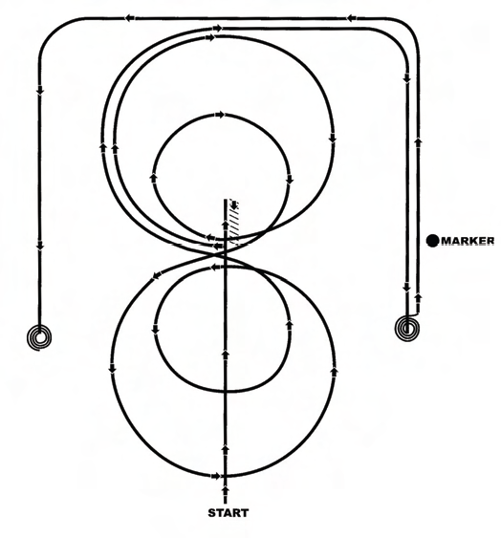

**Pattern 1**

1. Start at end of arena. Run down middle past center marker to a

sliding stop.

2. Back at least 10 feet to center. 1/4 turn to left.

3. Pick up right lead, large fast circle, small slow circle.

4. Change leads to left, large fast circle, small slow circle.

5. Change leads to right, do not close this circle.

6. Run around end of arena and down the side (approximately 20 feet

from fence) past center marker and come to a sliding stop.

7. Complete 3 1/2 spins to the right.

8. Continue back down side and end of arena to other side (approximately

20 feet from fence) go past center marker and come to a sliding

stop.

9. Complete 3 1/2 spins to the left.

10. Hesitate to complete pattern.

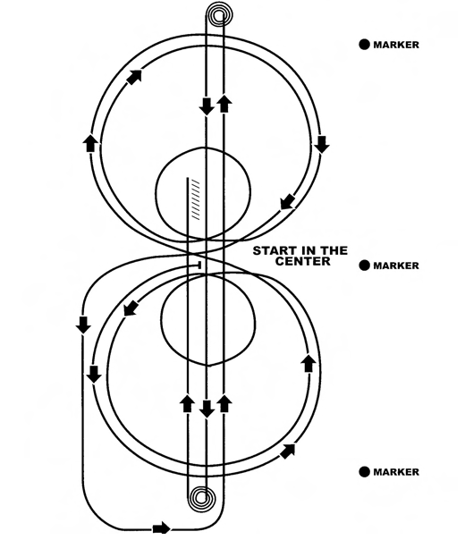

**Pattern 2**

**Mandatory Marker Along Fence or Wall**

Trot to center of arena and stop. Start pattern facing toward judge.

1. Pick up left lead, complete three circles to the left. The first one

large and fast, the second small and slow, the third large and fast.

2. Change leads at center of arena.

3. Complete three circles to the right. The first one large and fast, the

second small and slow, the third large and fast.

4. Change leads at center of arena.

5. Do not stop, continue on to run downs.

6. Run to far end past the marker to a sliding stop. Hesitate

7. Complete 3 1/2 spins to the left. Hesitate.

8. Run to far end past the marker to a sliding stop. Hesitate

9. Complete 3 1/2 spins to the right. Hesitate.

10. Run past center marker to a sliding stop. Hesitate.

11. Back at least 10 feet in a straight line. Hesitate

12. Hesitate to complete pattern.

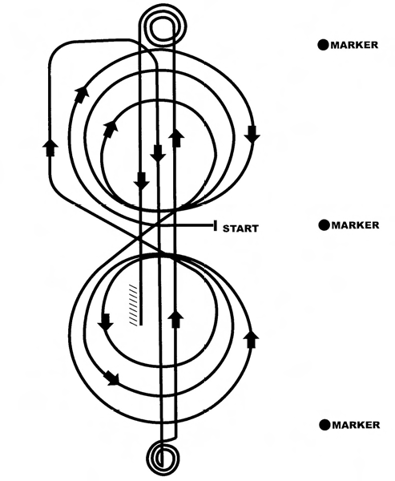

**Pattern 3**

**Mandatory Marker Along Fence or Wall**

Trot to center of arena and stop. Start pattern facing toward judge.

1. Begin on right lead and complete three circles to right, two large

fast circles followed by one small slow circle, change to left lead.

2. Complete three circles to left, two large, fast circles followed by one

small slow circle. Change to right lead.

3. Continue loping around end of arena without breaking gait.

4. Run up center of arena to far end past the end marker and come to

a sliding stop.

5. Complete 3 1/2 spins to the right.

6. Run up center of arena past the end marker, come to a sliding stop.

7. Complete 3 1/2 spins to the left.

8. Run back to middle of the arena past the center marker and come

to a sliding stop.

9. Back at least 10 feet in a straight line.

10. Hesitate to complete pattern.

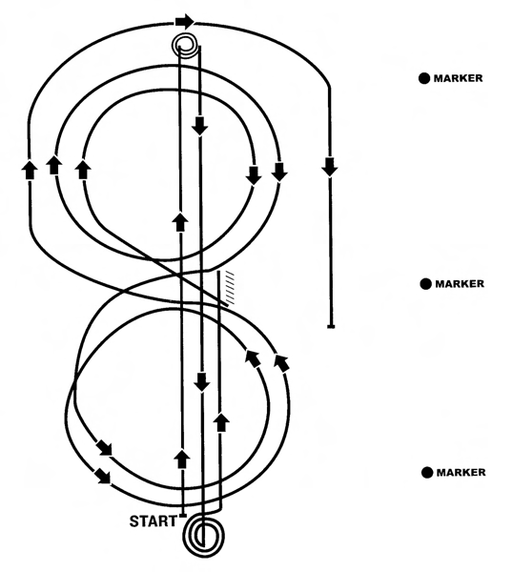

**Pattern 4**

1. Start at end of arena.

2. Run up center of arena past the end marker and come to a sliding

stop. Complete 3 1/2 spins to the left.

3. Run to other end of arena past the end marker and stop. Complete

3 1/2 spins to the right.

4. Run past the center marker and stop.

5. Back at least 10 feet in a straight line.

6. Complete 1/4 turn to the left, hesitate. Begin on right lead. Circle

to the right. Complete two circles to the right, the first one small

and slow and the second large and fast. Change leads at the center of the

arena.

7. Complete one small, slow circle and one large, fast circle. Change

leads to the right.

8. Run around end of arena to the other side, past the center marker,

at least 20 feet from fence and come to a sliding stop.

9. Hesitate to complete pattern.

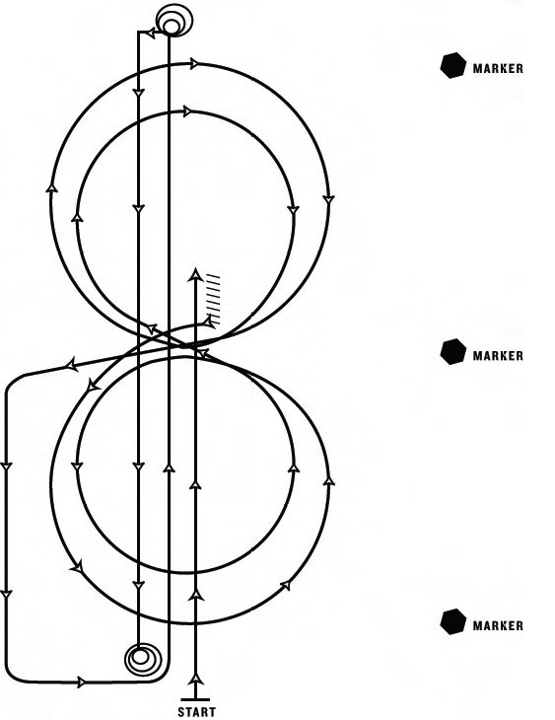

**Pattern 5**

This pattern works best when the exhibitor and cattle enter from the

same end of arena.

1. Start at end of arena.

2. Run past the center marker and stop.

3. Back up at least 10 feet.

4. Complete 1/4 turn to the left.

5. Complete 2 circles to the left, the first one large and fast and the

second small and slow. Change leads at the center of the arena.

6. Complete two circles to the right, the first one small and slow, the

second large and fast. Change leads at the center of the arena.

7. Continue around end of arena without breaking gait or changing

leads, run down center of arena past end marker, come to a square sliding

stop.

8. Complete 3 1/2 spins to the right.

9. Run down center of arena past end marker and come to a square

sliding stop.

10. Complete 3 1/2 spins to the left.

11. Hesitate to complete pattern.

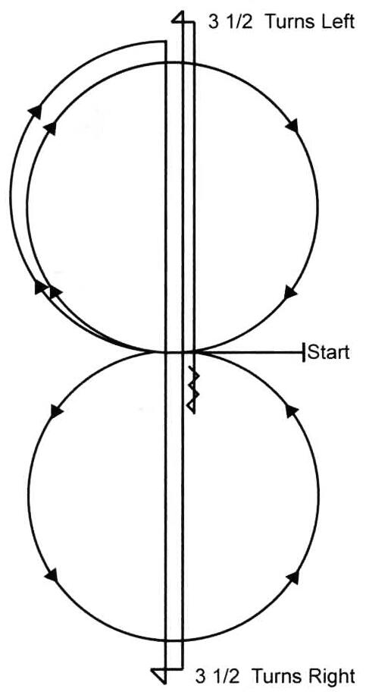

**PATTERN 6**

Trot to center of arena, stop. Start pattern facing towards judge

1. Beginning on the right lead lope one circle to the

right. Change leads to the left.

2. Complete one circle to the left. Change leads to the

right and go to the top of the arena.

3. Run down center of arena past the end marker and

come to a sliding stop.

4. Complete 2 1/2 spins to the right.

5. Run to the other end of the arena, past the end

marker and come to a sliding stop.

6. Complete 2 1/2 spins to the left.

7. Run past the center marker, stop, back at least 10

feet.

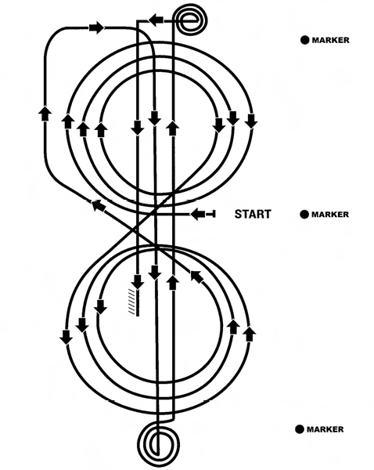

**Pattern 7**

Trot to center of arena and stop. Start pattern facing toward judge.

1. Begin at center of arena. Pick up right lead and complete three circles,

the first large, fast, the second small, slow, the third large, fast.

Change leads to the left.

2. Complete three circles: the first large and fast; the second small and

slow; the third large and fast. Change leads to the right.

3. Continue loping around end of arena without breaking gait or

changing leads.

4. Run down center of arena, past end marker and come to a sliding

stop. Hesitate.

5. Complete 3 1/2 spins to the right.

6. Run down center of arena past end marker and come to a sliding

stop. Hesitate.

7. Complete 3 1/2 spins to the left.

8. Run past center marker and come to a sliding stop.

9. Back up at least 10 feet.

10. Hesitate to complete pattern.

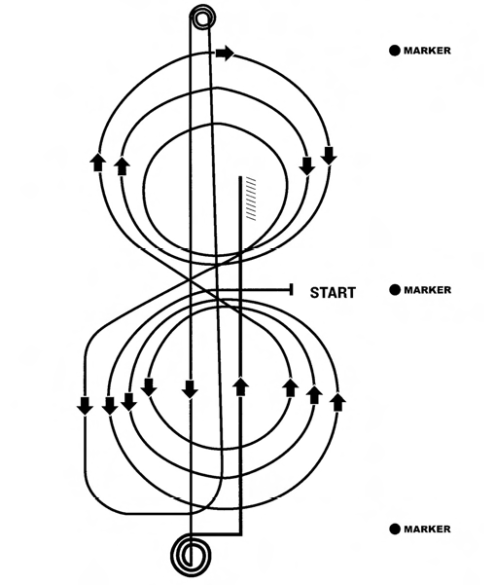

**Pattern 8**

Trot to center of arena and stop. Start pattern facing toward judge.

1. Beginning on the left lead complete three circles: two big fast circles;

then one small slow circle. Change leads to the right.

2. Complete three circles to the right: two large fast circles, then one

small slow circle. Change leads to the left.

3. Continue around end of arena without breaking gait or changing

leads, run down center of arena past end marker, come to a square sliding

stop.

4. Complete 3 1/2 spins to the left.

5. Run down center of arena past end marker and come to a square

sliding stop.

6. Complete 3 1/2 spins to the right.

7. Run down center of arena past center marker and come to a square

sliding stop.

8. Back up at least 10 feet.

9. Hesitate to complete pattern.

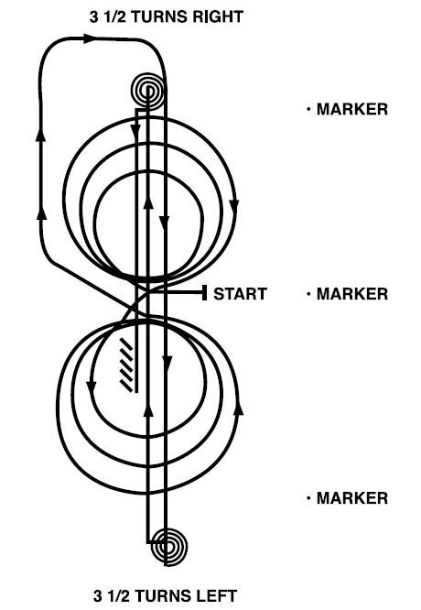

**Pattern 9**

Trot to center of arena, stop. Start pattern facing toward judge.

1. Beginning on the right lead complete 3 circles to the right; the first

circle small and slow followed by two large fast circles. Change leads at

the center of the arena.

2. Complete 3 circles to the left, the first circle small and slow followed

by two large fast circles. Change leads at the center of the arena.

3. Continue around end of arena without breaking gait or changing

leads, run down center of arena past end marker, and execute a square

sliding stop.

4. Complete 3 1/2 spins to the left.

5. Run down center of arena past end marker, and execute a square

sliding stop.

6. Complete 3 1/2 spins to the right.

7. Run down center of arena past center marker, and execute a square

sliding stop.

8. Back up at least 10 feet.

9. Hesitate to complete pattern.

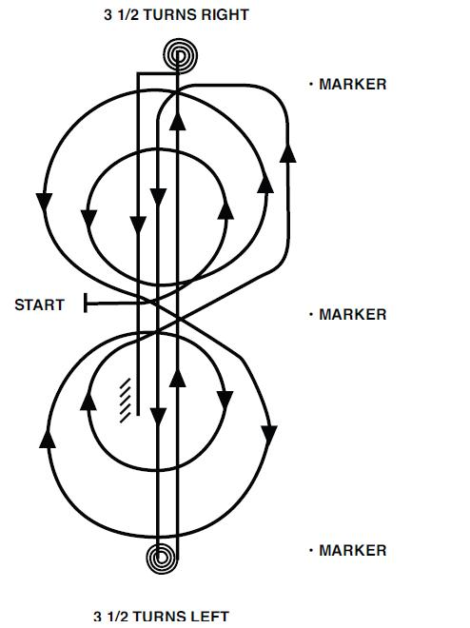

**Pattern 10**

Trot to center of arena, stop. Start pattern facing away from judge.

1. Beginning on the left lead, complete 2 circles to the left; the first

circle small and slow, the second circle large and fast.

2. Complete 2 circles to the right; the first circle large and fast, the

second circle small and slow. Change leads at the center of arena.

3. Continue around end of arena without breaking gait or changing

leads, run down center of arena past end marker, and execute a square

sliding stop.

4. Complete 3 1/2 spins to the left.

5. Run down center of arena past end maker, and execute a square

sliding stop.

6. Complete 3 1/2 spins to the right.

7. Run down center of arena past center marker, and execute a square

sliding stop.

8. Back up at least 10 feet.

9. Hesitate to complete pattern.

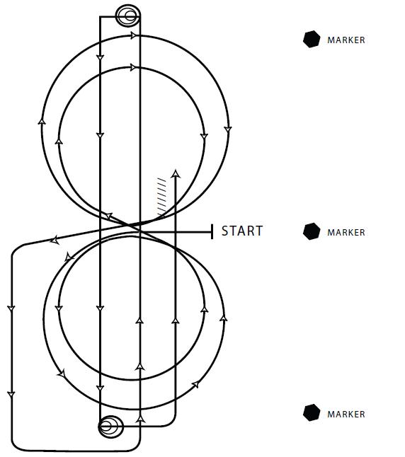

**Pattern 11**

Trot to center of arena, stop. Start pattern facing toward the judge.

1. Beginning on the left lead, complete 2 circles to the left; the first

circle large and fast, the second circle small and slow. Change leads at the

center of the arena.

2. Complete 2 circles to the right; the first circle large and fast, the

second circle small and slow. Change leads at the center of arena.

3. Continue around end of arena without breaking gait or changing

leads, run down center of arena past end marker, and execute a square

sliding stop.

4. Complete 3 1/2 spins to the left.

5. Run down center of arena past end maker, and execute a square

sliding stop.

6. Complete 3 1/2 spins to the right.

7. Run down center of arena past center marker, and execute a square

sliding stop.

8. Back up at least 10 feet.

9. Hesitate to complete pattern.

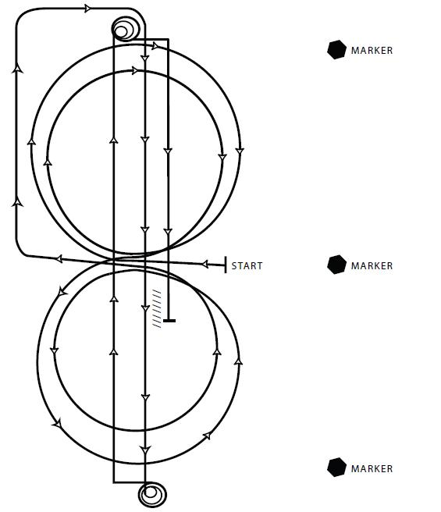

**Pattern 12**

Trot to center of arena, stop. Start pattern facing toward judge.

1. Beginning on the right lead complete 2 circles to the right; the first

circle large and fast and the second small and slow. Change leads at the

center of the arena.

2. Complete 2 circles to the left, the first circle large and fast and the

second small and slow. Change leads at the center of the arena.

3. Continue around end of arena without breaking gait or changing

leads, run down center of arena past end marker, and execute a square

sliding stop.

4. Complete 3 1/2 spins to the left.

5. Run down center of arena past end marker, and execute a square

sliding stop.

6. Complete 3 1/2 spins to the right.

7. Run down center of arena past center marker, and execute a square

sliding stop.

8. Back up at least 10 feet.

9. Hesitate to complete pattern.

|  |  |
| --- | --- |
| Pattern 1  1. Stop and back up and 1/4 turn  2. Right circles  3. Left circles  4. Stop  5. 3 1/2 right spins  6. Stop  7. 3 1/2 left spins  *Pattern 2  1. Left circles  2. Right circles  3. Stop  4. 3 1/2 left spins  5. Stop  6. 3 1/2 right spins  7. Stop and back up  *Pattern 3  1. Right circles  2. Left circles  3. Stop  4. 3 1/2 right spins  5. Stop  6. 3 1/2 left spins  7. Stop and back up  Pattern 4  1. Stop  2. 3 1/2 left spins  3. Stop  4. 3 1/2 right spins  5. Stop and back up and 1/4 turn  6. Right circles and left circles  7. Stop  Pattern 5  1. Stop and back up and 1/4 turn  2. Left circles  3. Right circles  4. Stop  5. 3 1/2 right spins  6. Stop  7. 3 1/2 left spins  *Pattern 6  1. Right circle  2. Left circle  3. Stop  4. 2 1/2 right spins  5. Stop  6. 2 1/2 left spins  7. Stop and back up | *Pattern 7  1. Right circles  2. Left circles  3. Stop  4. 3 1/2 right spins  5. Stop  6. 3 1/2 left spins  7. Stop and back up  *Pattern 8  1. Left circles  2. Right circles  3. Stop  4. 3 1/2 left spins  5. Stop  6. 3 1/2 right spins  7. Stop and back up  *Pattern 9  1. Right circles  2. Left circles  3. Stop  4. 3 1/2 left spins  5. Stop  6. 3 1/2 right spins  7. Stop and back up  *Pattern 10  1. Left circles  2. Right circles  3. Stop  4. 3 1/2 left spins  5. Stop  6. 3 1/2 right spins  7. Stop and back up  *Pattern 11  1. Left circles  2. Right circles  3. Stop  4. 3 1/2 left spins  5. Stop  6. 3 1/2 right spins  7. Stop and back up  *Pattern 12  1. Right circles  2. Left circles  3. Stop  4. 3 1/2 left spins  5. Stop  6. 3 1/2 right spins  7. Stop and back up  *This pattern may be used as a lope-in pattern; |

The Working Cow Horse patterns are divided into sets of seven maneuver groups, which are scored as described below. These patterns break down as follows:

# P – CLASSES

Classes may be added/deleted from time to time at the discretion of the Board of Directors for sanctioning / sponsorship purposes. Show organizers may select classes from those available but must meet criteria set for sanctioning. Classes will be reviewed at the Annual General Meeting and finalized prior to the first show of the new season.

All riders and horse owners must be members of ORCHA to show in ORCHA sanctioned classes at ORCHA approved shows. All riders must be members of ORCHA to show at all ORCHA sanctioned shows, jackpots or to participate at practices, clinics, workshops or any other club events.

Classes will pay back according to the ORCHA payback schedule. All show expenses will be deducted from the individual classes' purses prior to calculating payback. Payback may also consist of non-monetary items.

# ORCHA CLASSES

1 – Open

2 – Non Pro

3 – Intermediate Non Pro

4 – Novice Horse

5 – Open Boxing

6 – ORCHA Youth

7 – Ltd Non Pro

8 – Green as Grass

9 – Open Herd Work

# CLASS CONDITIONS

1. OPEN – Subject to the general conditions, any rider holding a valid ORCHA card may show any horse in this class. The rider must use one hand with split or romal reins. Points for year-end awards shall be calculated on total monies earned by each horse only.

Maneuvers in this class are:

Reining – One of 12 patterns will be used.

Cow Work - Boxing

- Fencing

- Circling

1. NON-PRO – Open to any rider holding a Non-Pro status as per ORCHA rules. A Non-Pro horse must be owned by the Non-Pro or his/her immediate family or may be owned by a corporation so long as the Non-Pro or an immediate family member owns 100% of the corporation. The rider must use one hand with split or romal reins. Year-end awards shall be calculated on total monies earned for each horse/rider combination.

Maneuvers in this class are:

Reining – One of 12 patterns will be used.

Cow Work - Boxing

- Fencing

- Circling

1. INTERMEDIATE Non Pro – Subject to general conditions a non-pro rider holding a valid ORCHA card and whose previous year’s ORCHA total earnings** are not in excess of $450.00. A Non-Pro horse must be owned by the Non-Pro or his/her immediate family or may be owned by a corporation so long as the Non-Pro or an immediate family member owns 100% of the corporation. The rider may use one or two hands but must complete the class as started. Year-end awards shall be calculated total monies earned by each horse/rider combination.

Maneuvers in this class are:

Reining – One of 12 patterns will be used.

Cow Work - Boxing

- Fencing

- Circling

1. NOVICE HORSE – Subject to general conditions but restricted to horses that have less than $1000.00 in ORCHA life time earnings at the beginning of the show season. May be ridden by any level of rider holding a valid ORCHA card. May be ridden one or two hands but must complete the class as started. Year-end awards shall be calculated on total monies earned by the horse during the show season.

Maneuvers in this class are:

Reining – One of 12 patterns will be used.

Cow Work - Boxing

- Fencing

- Circling

1. Open Boxing – Subject to general conditions, any rider holding a valid ORCHA card. Contestants in this class do not have to own the horse they ride, but the horse must be owned by an ORCHA member. The rider must use one hand throughout this class. Year-end awards shall be calculated on total monies earned for each horse.

Maneuvers in this class are:

Reining – One of 12 patterns will be used.

Cow Work - Boxing

* + - 50 seconds working time

1. ORCHA YOUTH – Limited to any ORCHA member, 18 years of age or younger as of January 1st. Contestants in this class do not have to own the horse they ride, but the horse must be owned by an ORCHA member. Horses are to be shown one or two handed. Regular cow horse reining patterns to apply. Year-end awards shall be calculated on total monies earned by the rider only; rider may show once per class.

No stallions, monorchid or cryptochid horses, regardless of age, will be permitted in any youth class.

Helmets are mandatory for any competitor in the Youth Class. Proper fitting equipment must be used at all times.

Maneuvers in this class are:

Reining – One of 12 patterns will be used.

Cow Work - Boxing

- 50 seconds working time

1. Ltd Non Pro – Subject to general conditions a non-pro rider holding a valid ORCHA card, and who has not fenced a cow more than 3 times in any judged event prior to the start of the ORCHA season qualifies for the Ltd Non Pro Class for the entire show season. A Non-Pro horse must be owned by the Non-Pro or his/her immediate family or may be owned by a corporation so long as the Non-Pro or an immediate family member owns 100% of the corporation. The rider may use one or two hands but must complete the class as started. Year-end awards shall be calculated on total monies earned by each horse/rider combination.

Maneuvers in this class are:

Reining – One of 12 patterns will be used.

Cow Work - Boxing

- 50 seconds working time

1. GREEN AS GRASS – Subject to general conditions a non-pro rider holding a valid ORCHA card, whose previous year’s ORCHA total earnings** are not in excess of $150.00. The rider may use one or two hands but must complete the pattern as started. Contestants in this class do not have to own the horse they ride, but the horse must be owned by an ORCHA member. Year-end awards shall be calculated on total monies each for each rider only; rider may show once per class.

Maneuvers in this class are:

Reining – One of 12 patterns will be used. **\*\*Simple lead change will not be penalized.\*\***

Cow Work - Boxing

- 50 seconds working time

1. **OPEN HERD WORK -** Subject to the general conditions, any rider holding a valid ORCHA card may show any horse in this class. The rider must use one hand with romal reins or one or two hands with split reins. Points for year-end awards shall be calculated on total monies earned by each horse only.

Maneuvers in this class are:

Herd Work – 2 ½ minutes of working time.

** Previous year’s ORCHA total earnings is the sum of rider’s earnings for all classes in which the rider participated in during the previous ORCHA season.

**PAYOUTS**

ORCHA Payouts shall be based on the following. Earnings throughout the year using this schedule will determine year-end awards.



**JUDGING**

The Judge's decision is final.

The horses will be judged with emphasis placed on attitude, manners and movement.

The Judge is compelled to disqualify any horse that he/she feels is being exhibited in a manner which is cruel, abusive and inhumane.

The exhibition of a horse that has a cut or abrasion showing clear evidence of fresh blood in the mouth, nose, chin, shoulder barrel, flank or hip would result in disqualification.

# ORCHA JUDGES COMMITTEE AND JUDGES APPROVAL

ORCHA will form a judges committee comprising of at least two (2) Directors. This committee's purpose is to administer ORCHA Judge's Program, which is to oversee the qualification and appointments of ORCHA judges.

# YEAR END AWARDS

The organization will recognize achievements of its members by annually presenting an award to the highest money earner (Champion) and the second highest money earner (Reserve Champion) in each class based on the total annual monies earned at the ORCHA sanctioned events in one calendar year (October 1st to September 30th). Tabulations are calculated as indicated in the Class conditions only from the day the paid membership received to the end of the award year.

Ties will be broken by higher cow points; if equal cow points, 2 awards will be given.

In order to qualify for year-end awards, Champion and Reserve riders must have competed in the said class at least 50% of the total times offered at shows. In order for monies earned to be eligible for year-end awards, rider and horse owner must be a member in good standing of ORCHA.